To use this template, make a copy by selecting FILE / MAKE A COPY to make your own Google Docs file, or FILE / DOWNLOAD to create a word doc if you’d prefer to work offline.

## **Project “PsycoMasters” 1.5-Page GDD**

*Psyren(manga) meets Diablo*

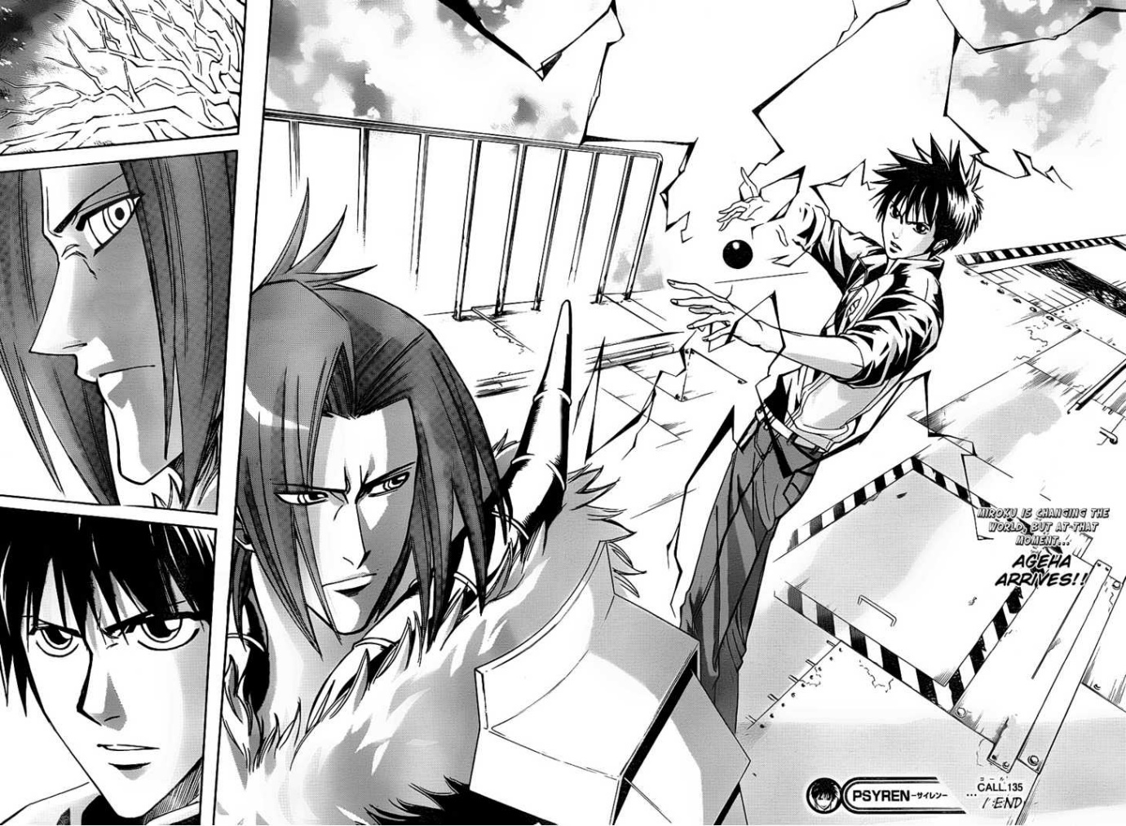

**Genre:** 3rd person action rpg, fixed camera  
**Target Audience:** Pg-13

**Controls:** Mouse and keyboard

**Thematic Setting:** Alternate Earth, medieval

**Tech Stack:** Unity 2018.4, Audacity, Asset Store for 3d and UI

**Platform(s):** Steam

**MVP Game Moment:** 2 minutes of simple linear flow battling 3 or 4 enemies

**Game Summary:** Adventure game with psionic abilities. The hero attempts to thwart the villain using creativity and imagination as he lacks the powers and ability of the villain.

**Core Player Experience:**

Connection to the game world and the world around them. Having the ability to change the world around them. The only limit to gameplay is imagination.

**Central Story Theme:** Responsible hero/ not chosen one

**Design Pillar:** Psionic powers overcoming challenges

**Remarkability:** Wide ranging abilities, not just click cycles

**Anticipated Steam Early Access Launch date:** End of February 2020

**Feature Development Priorities:**

* Real time combat
* Rpg abilities and stats
* Level building
* Branching dialogue system
* Inventory, loot

**Reference Games:**

Golden sun, diablo

**Game 2 Ideas:**

Game based on psychic powers

Psychometry = able to use any weapon/ skill as advances through t the game. Increased crit chance.

Telekinesis: = able to move game objects – small at first and then larger objects as you advance. Increases strength or hp.

Teleportation = able to teleport other objects, chance of object reappearing in the wrong spot.

Psionic barrier

Psionic enhanced unarmed combat